**Wire-Frame Design**

**STORE SALES PREDICTION**

|  |  |
| --- | --- |
| Written By | Mohammed Salman |
| Document Version | 1.0 |
| Last Revised Date | 26-11-2022 |

**Document Change Control Record**

|  |  |  |  |
| --- | --- | --- | --- |
| **Version** | **Date** | **Author** | **Comments** |
|  |  |  |  |
|  |  |  |  |
|  |  |  |  |
|  |  |  |  |
|  |  |  |  |
|  |  |  |  |
|  |  |  |  |
|  |  |  |  |
|  |  |  |  |
|  |  |  |  |
|  |  |  |  |
|  |  |  |  |
|  |  |  |  |
|  |  |  |  |
|  |  |  |  |
|  |  |  |  |

**Reviews**

|  |  |  |  |
| --- | --- | --- | --- |
| **Version** | **Date** | **Reviewer** | **Comments** |
|  |  |  |  |

**Approval Status:**

|  |  |  |  |  |
| --- | --- | --- | --- | --- |
| **Version** | **Review date** | **Reviewed By** | **Approved By** | **Comments** |
|  |  |  |  |  |

# Homepage or Predict page

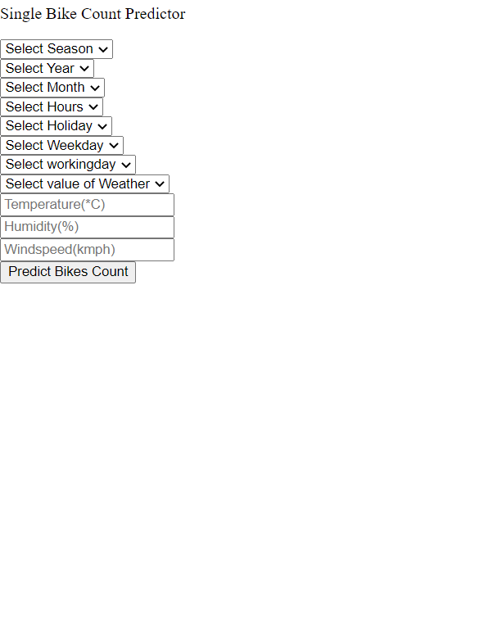

After the user will give inputs there will be predict button, on clicking predict button the next page will open which will be the result page where the prediction will be shown for the given inputs. Below is the image how the result page will look like:

